Kappa Kamp Leadership Program
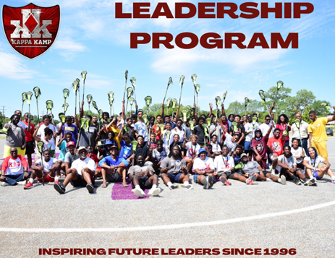
What we have done:
- Outstanding leadership and mentoring program that has served over 2,900 youth since 1996.
- Improved academic, social and moral values among participants.
- Expanded college readiness programming (Over 80% of participants attending 2-year, 4-year institutions or military service)
- Created a national model for college readiness, entrepreneurship, and youth development. Created a national model for college readiness, business ownership and youth development.
- Expanded the thoughts and ideas of Leadership and Financial Empowerment for young men.
- Supported a stronger and more advanced workforce which includes College, Military and Trade
- Lifelong friends from various backgrounds and communities across the nation.
How we do it:
- Provide enrichment activities for ages 12-16.
- Motivate students to seek higher levels of achievement.
- Expose students to activities rich in cultural information and experiences.
- Develop students' reading, writing, and speaking skills while involved in each camp.
- Provide experiences that focus on science technology and survival.
- Allow campers to make friends from around the world in a structured, safe environment.
- Provide a spiritual faith-based atmosphere for human growth and development.
- Provide character education and citizenship in an ethical environment.

Course Descriptions

Fundamentals of Leadership & Entrepreneurship

Our Fundamentals of Leadership & Entrepreneurship (FLE) course is a one-week immersion into the nuts and bolts of the business world by challenging the students to create a viable business. Kamper’s will be taught the fundamentals of leadership, entrepreneurship, marketing, accounting, operations, and organizational behavior, while coming to understand the integrated role these functions play in every successful endeavor. Leadership will be taught from the perspective of servant leadership. Additionally, they will be separated into teams and will generate their own business ideas. The Kamper’s will submit these ideas in the form of business plans and prototypes. The team with the best plan will receive a monetary prize.

The Principles of STEM
The Principles of STEM (Science, Technology, Engineering, and Mathematics) course is designed to introduce Kamper’s to STEM related studies and learning experiences to inspire their interest in STEM fields. In keeping with the Kamp’s focus on moving the Kamper’s from theory to application, each of the Kamper’s group projects from FLE will include a STEM component.

Leadership in Team Sports (Basketball & Soccer)
Kamper’s will be taught leadership traits and values through participating in team sports (basketball and soccer). Emphasis will be placed on sportsmanship and ethical adherence to the rules of the games. Additionally, Kamper’s will also be taught the fundamentals of each sport.

Financial Literacy
Making effective financial decisions and knowing how to manage money are skills critical to enjoying a secure financial future. This course takes a practical approach to providing Kamper’s with the skills needed to address the financial issues faced by them. The content is specifically tailored to young, minority males utilizing the GLAD/CARE model.

KAPPA KAMP PROGRAM CONTACT
Kappa Kamp Director
214-379-5575
Maurice A. West; mailto:kappakamp@pqc.edu

